**7PAM2000 Applied Data Science 1**

**Assignment 1: Visualization**

Fawas Afsal

SRN: 22080258

Link to the repository:

**Introduction**

Three different visualisation techniques were applied to the "US_Crime_Rates_1960_2014" dataset:

1) Line plot

2) Bar Chart

3) Pie Chart

All graphs are plotted using the "pyplot" function, and datasets are read using the pandas tool. The "Kaggle" open-source, free database provided the dataset. I've discovered a dataset that displays the crime rates in the US from 1960 to 2014. It includes the overall population during that time as well as various crimes like violent, forcible rape, robbery, theft of vehicles, burglary, murder, property, and larceny theft.

The website provided the dataset: <https://www.kaggle.com/datasets/mahmoudshogaa/us-crime-rates-1960-2014>

**Line Plot**

The graph shows the trends in different types of crime rates (Violent, Property, Murder, and Robbery) over the years from 1960 to 2014. The time period (year) is represented by the X-axis, and the number of crimes throughout the span is displayed in crime rates per 100,000 individuals on the Y-axis.

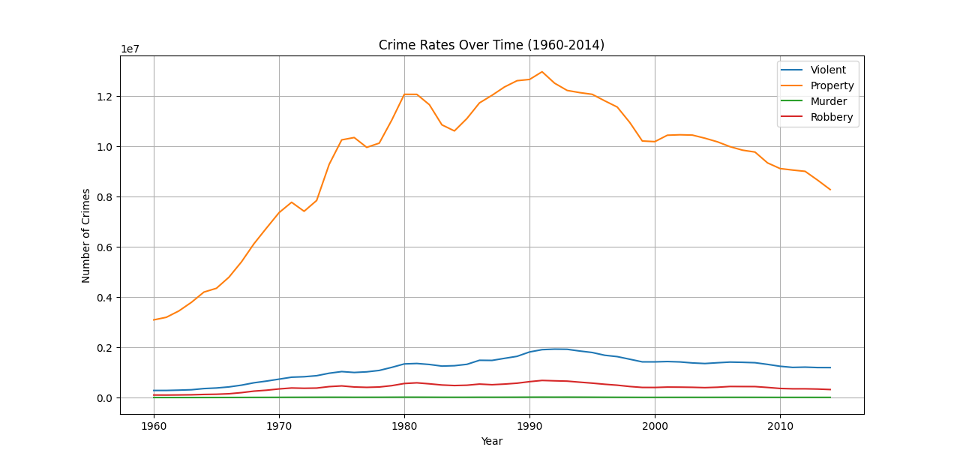

Violent Crime: The plot reveals fluctuations, with a notable increase from the 1960s to the early 1990s, followed by a decreasing trend.

Property Crime: Similar to violent crime, property crime rates increased till the early 1990s and then consistently decreased.

Murder & Robbery: Both show fluctuations, reaching peaks around the early 1990s, followed by a decline.

The trends in the graph depict a significant increase in crime rates, particularly violent and property crimes, from the 1960s to the early 1990s. However, from the early 1990s onward, there was a noticeable and consistent decline in these crime rates. It indicates a positive shift in the overall safety and security scenario, although localized fluctuations may still occur due to various factors influencing different types of crimes.

**Bar Chart**

The bar chart showing the total number of crimes in selected years (1980, 1990, 2000, 2010, and 2014). This chart displays how the total number of crimes evolved in these specific years. The X-axis represents the time period (year), and the Y-axis shows the total number of crimes over the period expressed as crime rates per 100,000 people.

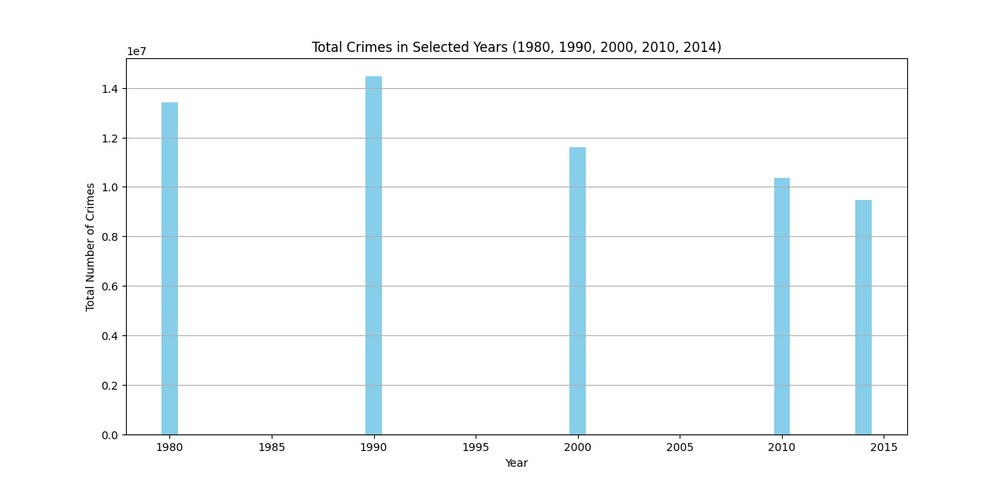

1980: The total number of crimes in 1980 is relatively moderate compared to the subsequent years.

1990: There is a noticeable increase in the total number of crimes by the year 1990. This period, especially the late 1980s and early 1990s, saw a significant rise in overall crime rates across various categories (violent, property, etc.).

2000: The graph might show a decrease in the total number of crimes compared to the peak in 1990.

2010 and 2014: The trend continues to show a decline in the total number of crimes.

The graph demonstrates the fluctuation and overall change in the total number of crimes in the selected years. There appears to be a significant increase from 1980 to 1990.However, from 1990 onward, there's a noticeable and consistent decline in the total number of crimes.

**Pie Chart**

The pie chart shows the distribution of crime types in the year 2014. This chart displays the proportion of different crime categories (Violent, Property, and Murder) in the total reported crimes for that specific year.

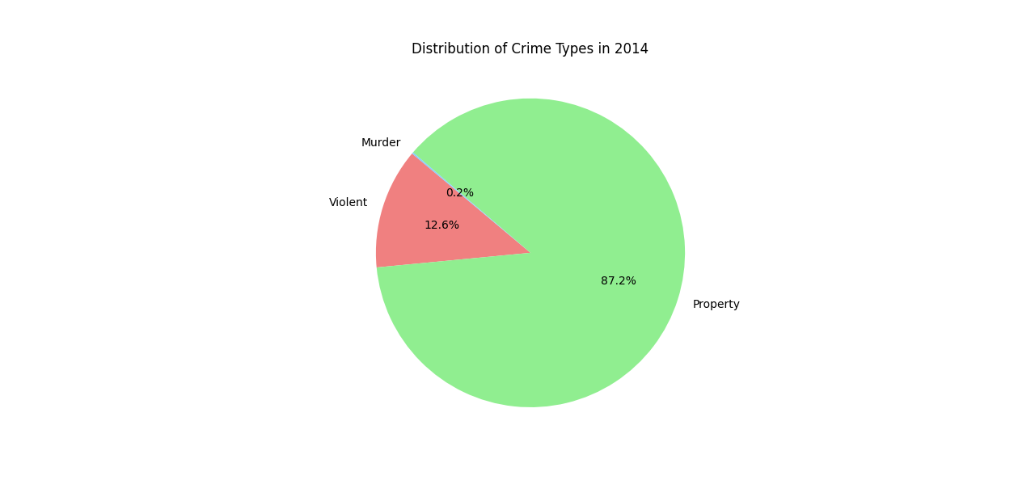

The pie chart reveals that Violent crimes represent a significant proportion of reported crimes in 2014.Property crimes constitute a substantial portion of reported crimes in 2014 as well. Despite having the smallest portion in the pie chart, the murder category is nonetheless important because it reflects one of the most terrible and serious types of criminal activity. It illustrates that property crimes had the highest share in 2014, followed by violent crimes and then murder.